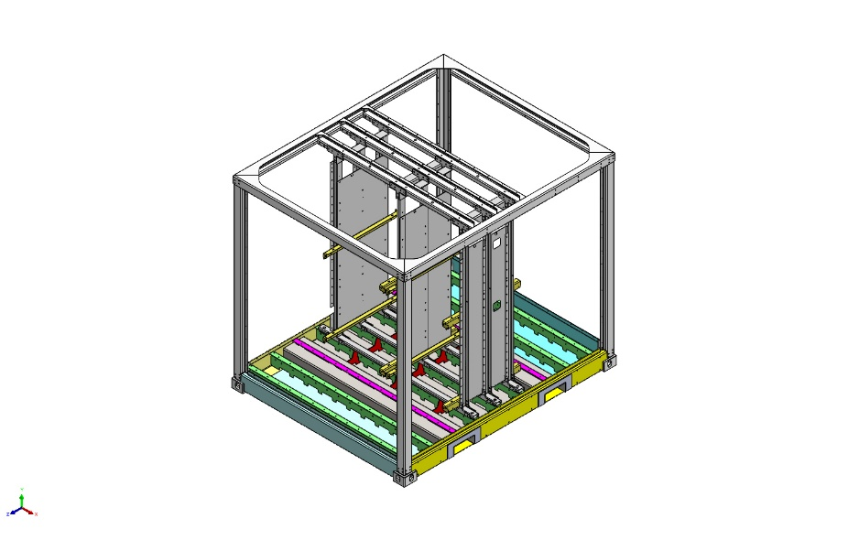 | Simulation of P000014110FLR  Date: Tuesday, June 9, 2026  Designer: Solidworks  Study name: Static 1  Analysis type: Static  Table of Contents  Description 1  Assumptions 2  Model Information 3  Study Properties 8  Units 9  Material Properties 10  Loads and Fixtures 20  Connector Definitions 21  Contact Information 22  Mesh information 23  Sensor Details 23  Resultant Forces 23  Beams 23  Study Results 23  Conclusion 23

Description
No Data

Assumptions

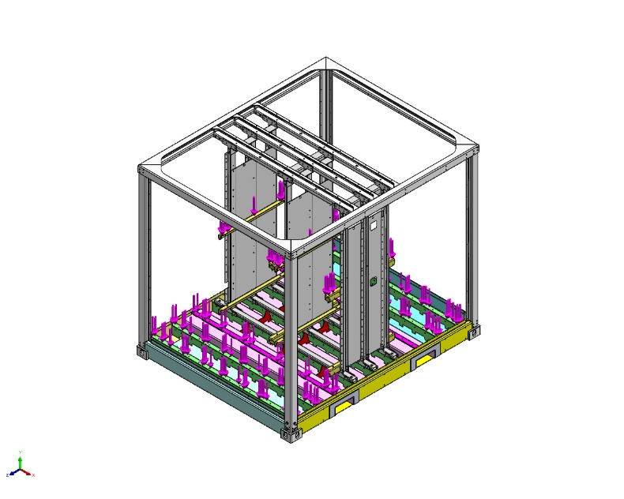  Original Model | 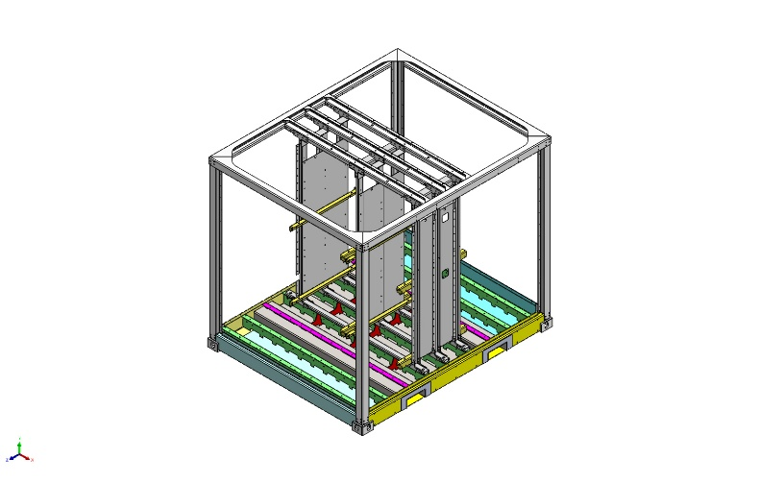  Model Analyzed

Model Information

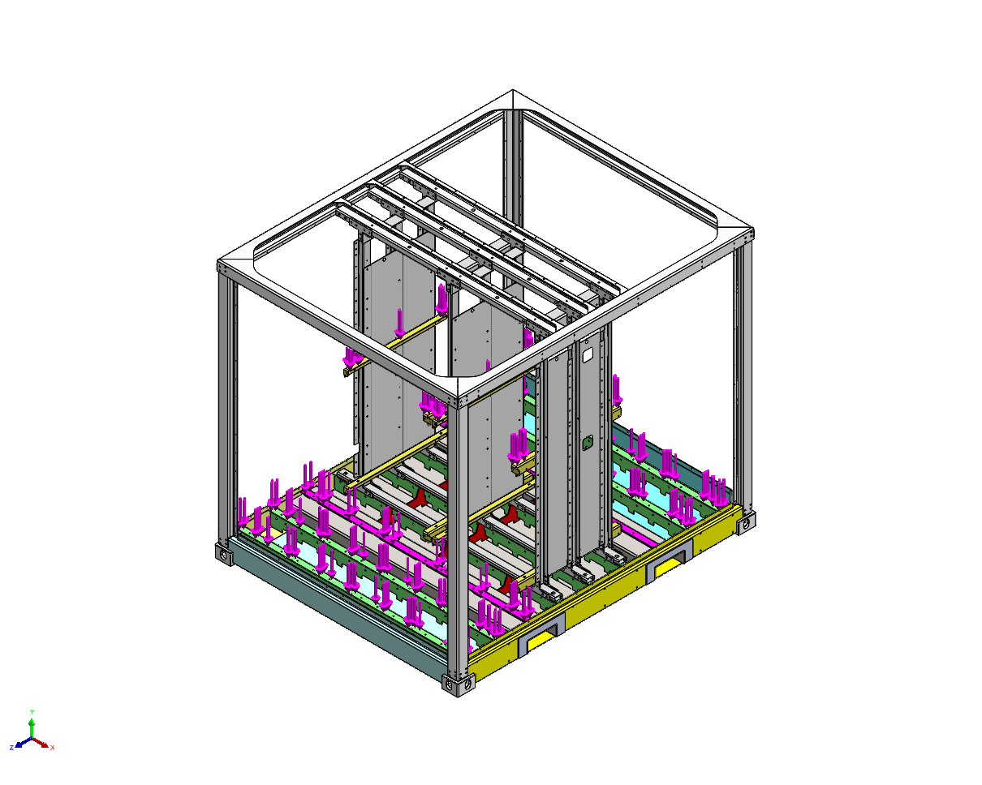
Model name: P000014110FLR
Current Configuration: Default
Solid Bodies
Document Name and Reference | Treated As | Volumetric Properties | Document Path/Date Modified
Cut-Extrude1 | Solid Body | Mass:18.295 kg  Volume:0.00234552 m^3  Density:7,800 kg/m^3  Weight:179.291 N | G:\03_Projects_Business_Dev\00056 e-PU10 V1\04_Engineering\05) Mechanical stress analysis\e-PU battery rack brake V6 (e-stop) 2025\FEM2P000009263.SLDPRT  May 6 10:33:00 2024
Cut-Extrude1 | Solid Body | Mass:18.295 kg  Volume:0.00234552 m^3  Density:7,800 kg/m^3  Weight:179.291 N | G:\03_Projects_Business_Dev\00056 e-PU10 V1\04_Engineering\05) Mechanical stress analysis\e-PU battery rack brake V6 (e-stop) 2025\FEM2P000009263.SLDPRT  May 6 10:33:00 2024
Cut-Extrude1 | Solid Body | Mass:18.295 kg  Volume:0.00234552 m^3  Density:7,800 kg/m^3  Weight:179.291 N | G:\03_Projects_Business_Dev\00056 e-PU10 V1\04_Engineering\05) Mechanical stress analysis\e-PU battery rack brake V6 (e-stop) 2025\FEM2P000009263.SLDPRT  May 6 10:33:00 2024
Ø13.0 (13) Diameter Slot2 | Solid Body | Mass:0.812536 kg  Volume:0.000104171 m^3  Density:7,800 kg/m^3  Weight:7.96285 N | G:\03_Projects_Business_Dev\00056 e-PU10 V1\04_Engineering\05) Mechanical stress analysis\e-PU battery rack brake V6 (e-stop) 2025\FEM2P000010107.SLDPRT  Nov 14 17:04:42 2023
Ø13.0 (13) Diameter Slot2 | Solid Body | Mass:0.812536 kg  Volume:0.000104171 m^3  Density:7,800 kg/m^3  Weight:7.96285 N | G:\03_Projects_Business_Dev\00056 e-PU10 V1\04_Engineering\05) Mechanical stress analysis\e-PU battery rack brake V6 (e-stop) 2025\FEM2P000010107.SLDPRT  Nov 14 17:04:42 2023
Ø13.0 (13) Diameter Slot2 | Solid Body | Mass:0.812536 kg  Volume:0.000104171 m^3  Density:7,800 kg/m^3  Weight:7.96285 N | G:\03_Projects_Business_Dev\00056 e-PU10 V1\04_Engineering\05) Mechanical stress analysis\e-PU battery rack brake V6 (e-stop) 2025\FEM2P000010107.SLDPRT  Nov 14 17:04:42 2023
CSK for M1.6 Countersunk Flat Head Screw2 | Solid Body | Mass:17.2863 kg  Volume:0.00221619 m^3  Density:7,800 kg/m^3  Weight:169.406 N | G:\03_Projects_Business_Dev\00056 e-PU10 V1\04_Engineering\05) Mechanical stress analysis\e-PU battery rack brake V6 (e-stop) 2025\FEM2P000010224.SLDPRT  May 6 10:31:28 2024
CSK for M1.6 Countersunk Flat Head Screw2 | Solid Body | Mass:17.2863 kg  Volume:0.00221619 m^3  Density:7,800 kg/m^3  Weight:169.406 N | G:\03_Projects_Business_Dev\00056 e-PU10 V1\04_Engineering\05) Mechanical stress analysis\e-PU battery rack brake V6 (e-stop) 2025\FEM2P000010224.SLDPRT  May 6 10:31:28 2024
CSK for M1.6 Countersunk Flat Head Screw2 | Solid Body | Mass:17.2863 kg  Volume:0.00221619 m^3  Density:7,800 kg/m^3  Weight:169.406 N | G:\03_Projects_Business_Dev\00056 e-PU10 V1\04_Engineering\05) Mechanical stress analysis\e-PU battery rack brake V6 (e-stop) 2025\FEM2P000010224.SLDPRT  May 6 10:31:28 2024
Ø13.0 (13) Diameter Slot2 | Solid Body | Mass:1.19805 kg  Volume:0.000153596 m^3  Density:7,800 kg/m^3  Weight:11.7408 N | G:\03_Projects_Business_Dev\00056 e-PU10 V1\04_Engineering\05) Mechanical stress analysis\e-PU battery rack brake V6 (e-stop) 2025\FEM2P000010308.SLDPRT  Nov 14 17:04:42 2023
Ø13.0 (13) Diameter Slot2 | Solid Body | Mass:1.19805 kg  Volume:0.000153596 m^3  Density:7,800 kg/m^3  Weight:11.7408 N | G:\03_Projects_Business_Dev\00056 e-PU10 V1\04_Engineering\05) Mechanical stress analysis\e-PU battery rack brake V6 (e-stop) 2025\FEM2P000010308.SLDPRT  Nov 14 17:04:42 2023
Ø13.0 (13) Diameter Slot2 | Solid Body | Mass:1.19805 kg  Volume:0.000153596 m^3  Density:7,800 kg/m^3  Weight:11.7408 N | G:\03_Projects_Business_Dev\00056 e-PU10 V1\04_Engineering\05) Mechanical stress analysis\e-PU battery rack brake V6 (e-stop) 2025\FEM2P000010308.SLDPRT  Nov 14 17:04:42 2023
CSK for M1.6 Countersunk Flat Head Screw6 | Solid Body | Mass:24.6142 kg  Volume:0.00315567 m^3  Density:7,800 kg/m^3  Weight:241.219 N | G:\03_Projects_Business_Dev\00056 e-PU10 V1\04_Engineering\05) Mechanical stress analysis\e-PU battery rack brake V6 (e-stop) 2025\FEM2P000010328.SLDPRT  May 6 10:29:12 2024
CSK for M1.6 Countersunk Flat Head Screw6 | Solid Body | Mass:24.6142 kg  Volume:0.00315567 m^3  Density:7,800 kg/m^3  Weight:241.219 N | G:\03_Projects_Business_Dev\00056 e-PU10 V1\04_Engineering\05) Mechanical stress analysis\e-PU battery rack brake V6 (e-stop) 2025\FEM2P000010328.SLDPRT  May 6 10:29:12 2024
CSK for M1.6 Countersunk Flat Head Screw6 | Solid Body | Mass:24.6142 kg  Volume:0.00315567 m^3  Density:7,800 kg/m^3  Weight:241.219 N | G:\03_Projects_Business_Dev\00056 e-PU10 V1\04_Engineering\05) Mechanical stress analysis\e-PU battery rack brake V6 (e-stop) 2025\FEM2P000010328.SLDPRT  May 6 10:29:12 2024
Fillet11  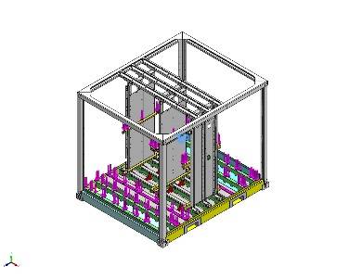 | Solid Body | Mass:12.3782 kg  Volume:0.00157523 m^3  Density:7,858 kg/m^3  Weight:121.306 N | G:\03_Projects_Business_Dev\00056 e-PU10 V1\04_Engineering\05) Mechanical stress analysis\Floor okt 2025\P000008405FLR.SLDPRT  Sep 9 07:22:34 2025
Fillet11  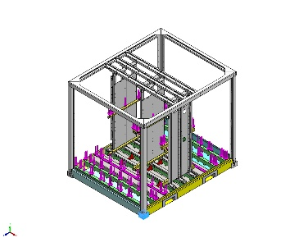 | Solid Body | Mass:12.3782 kg  Volume:0.00157523 m^3  Density:7,858 kg/m^3  Weight:121.306 N | G:\03_Projects_Business_Dev\00056 e-PU10 V1\04_Engineering\05) Mechanical stress analysis\Floor okt 2025\P000008405FLR.SLDPRT  Sep 9 07:22:34 2025
<P000003232>-<Fillet11> | Solid Body | Mass:12.3783 kg  Volume:0.00157524 m^3  Density:7,858.04 kg/m^3  Weight:121.307 N | G:\03_Projects_Business_Dev\00056 e-PU10 V1\04_Engineering\05) Mechanical stress analysis\Floor okt 2025\P000008411FLR.sldprt  Oct 13 12:59:26 2025
<P000003232>-<Fillet11> | Solid Body | Mass:12.3783 kg  Volume:0.00157524 m^3  Density:7,858.04 kg/m^3  Weight:121.307 N | G:\03_Projects_Business_Dev\00056 e-PU10 V1\04_Engineering\05) Mechanical stress analysis\Floor okt 2025\P000008411FLR.sldprt  Oct 13 12:59:26 2025
Boss-Extrude1  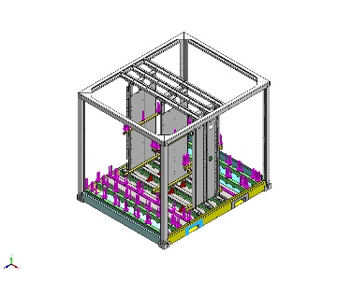 | Solid Body | Mass:0.0004618 kg  Volume:0.0004618 m^3  Density:1 kg/m^3  Weight:0.00452564 N | C:\Users\pdmdesktop\AppData\Local\Temp\swx82224\VC~~\P000014110FLR\Part1^P000014110FLR.sldprt  Jun 9 10:21:55 2026
Boss-Extrude1  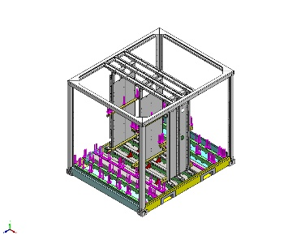 | Solid Body | Mass:0.0004618 kg  Volume:0.0004618 m^3  Density:1 kg/m^3  Weight:0.00452564 N | C:\Users\pdmdesktop\AppData\Local\Temp\swx82224\VC~~\P000014110FLR\Part1^P000014110FLR.sldprt  Jun 9 10:21:55 2026
Boss-Extrude1  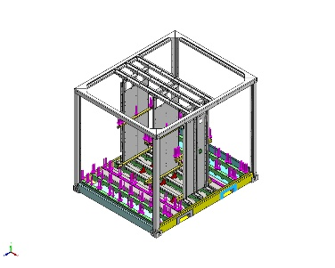 | Solid Body | Mass:0.0004618 kg  Volume:0.0004618 m^3  Density:1 kg/m^3  Weight:0.00452564 N | C:\Users\pdmdesktop\AppData\Local\Temp\swx82224\VC~~\P000014110FLR\Part1^P000014110FLR.sldprt  Jun 9 10:21:55 2026
Boss-Extrude1  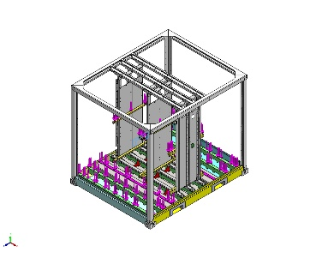 | Solid Body | Mass:0.0004618 kg  Volume:0.0004618 m^3  Density:1 kg/m^3  Weight:0.00452564 N | C:\Users\pdmdesktop\AppData\Local\Temp\swx82224\VC~~\P000014110FLR\Part1^P000014110FLR.sldprt  Jun 9 10:21:55 2026

Study Properties
Study name | Static 1
Analysis type | Static
Mesh type | Mixed Mesh
Thermal Effect: | On
Thermal option | Include temperature loads
Zero strain temperature | 298 Kelvin
Include fluid pressure effects from SOLIDWORKS Flow Simulation | Off
Solver type | FFEPlus
Inplane Effect: | Off
Soft Spring: | Off
Inertial Relief: | Off
Incompatible bonding options | Automatic
Large displacement | Off
Compute free body forces | On
Friction | Off
Use Adaptive Method: | Off
Result folder | SOLIDWORKS document (G:\03_Projects_Business_Dev\00056 e-PU10 V1\04_Engineering\05) Mechanical stress analysis\Floor okt 2025)

Units
Unit system: | SI (MKS)
Length/Displacement | mm
Temperature | Kelvin
Angular velocity | Rad/sec
Pressure/Stress | N/m^2

Material Properties
Model Reference | Properties | Components
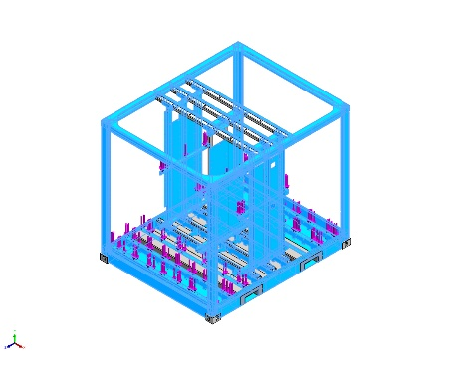 | Name: 1.0976 (S355MC)  Model type: Linear Elastic Isotropic  Default failure criterion: Unknown  Yield strength: 3.15e+08 N/m^2  Tensile strength: 4.9e+08 N/m^2  Elastic modulus: 2.1e+11 N/m^2  Poisson's ratio: 0.28  Mass density: 7,800 kg/m^3  Shear modulus: 7.9e+10 N/m^2  Thermal expansion coefficient: 1.1e-05 /Kelvin | SolidBody 1(Ø9.1 (9.1) Diameter Hole2)(FEM2P000013056-1/FEM2P000011093-1/FEM2P000009265-2/FEM2P000009247-10),  SolidBody 1(Ø9.1 (9.1) Diameter Hole2)(FEM2P000013056-1/FEM2P000011093-1/FEM2P000009265-2/FEM2P000009247-16),  SolidBody 1(Ø9.1 (9.1) Diameter Hole2)(FEM2P000013056-1/FEM2P000011093-1/FEM2P000009265-2/FEM2P000009247-17),  SolidBody 1(Ø9.1 (9.1) Diameter Hole2)(FEM2P000013056-1/FEM2P000011093-1/FEM2P000009265-2/FEM2P000009247-19),  SolidBody 1(Ø9.1 (9.1) Diameter Hole2)(FEM2P000013056-1/FEM2P000011093-1/FEM2P000009265-2/FEM2P000009247-20),  SolidBody 1(Ø9.1 (9.1) Diameter Hole2)(FEM2P000013056-1/FEM2P000011093-1/FEM2P000009265-2/FEM2P000009247-9),  SolidBody 1(Ø13.0 (13) Diameter Hole1)(FEM2P000013056-1/FEM2P000011093-1/FEM2P000009265-2/FEM2P000009740-1),  SolidBody 1(Ø13.0 (13) Diameter Hole1)(FEM2P000013056-1/FEM2P000011093-1/FEM2P000009265-2/FEM2P000009740-10),  SolidBody 1(Ø13.0 (13) Diameter Hole1)(FEM2P000013056-1/FEM2P000011093-1/FEM2P000009265-2/FEM2P000009740-11),  SolidBody 1(Ø13.0 (13) Diameter Hole1)(FEM2P000013056-1/FEM2P000011093-1/FEM2P000009265-2/FEM2P000009740-12),  SolidBody 1(Ø13.0 (13) Diameter Hole1)(FEM2P000013056-1/FEM2P000011093-1/FEM2P000009265-2/FEM2P000009740-25),  SolidBody 1(Ø13.0 (13) Diameter Hole1)(FEM2P000013056-1/FEM2P000011093-1/FEM2P000009265-2/FEM2P000009740-26),  SolidBody 1(Ø13.0 (13) Diameter Hole1)(FEM2P000013056-1/FEM2P000011093-1/FEM2P000009265-2/FEM2P000009740-27),  SolidBody 1(Ø13.0 (13) Diameter Hole1)(FEM2P000013056-1/FEM2P000011093-1/FEM2P000009265-2/FEM2P000009740-28),  SolidBody 1(Ø13.0 (13) Diameter Hole1)(FEM2P000013056-1/FEM2P000011093-1/FEM2P000009265-2/FEM2P000009740-29),  SolidBody 1(Ø13.0 (13) Diameter Hole1)(FEM2P000013056-1/FEM2P000011093-1/FEM2P000009265-2/FEM2P000009740-30),  SolidBody 1(Ø13.0 (13) Diameter Hole1)(FEM2P000013056-1/FEM2P000011093-1/FEM2P000009265-2/FEM2P000009740-31),  SolidBody 1(Ø13.0 (13) Diameter Hole1)(FEM2P000013056-1/FEM2P000011093-1/FEM2P000009265-2/FEM2P000009740-32),  SolidBody 1(Ø13.0 (13) Diameter Hole1)(FEM2P000013056-1/FEM2P000011093-1/FEM2P000009265-2/FEM2P000009740-33),  SolidBody 1(Ø13.0 (13) Diameter Hole1)(FEM2P000013056-1/FEM2P000011093-1/FEM2P000009265-2/FEM2P000009740-34),  SolidBody 1(Ø13.0 (13) Diameter Hole1)(FEM2P000013056-1/FEM2P000011093-1/FEM2P000009265-2/FEM2P000009740-35),  SolidBody 1(Ø13.0 (13) Diameter Hole1)(FEM2P000013056-1/FEM2P000011093-1/FEM2P000009265-2/FEM2P000009740-36),  SolidBody 1(Ø13.0 (13) Diameter Hole1)(FEM2P000013056-1/FEM2P000011093-1/FEM2P000009265-2/FEM2P000009740-8),  SolidBody 1(Ø13.0 (13) Diameter Hole1)(FEM2P000013056-1/FEM2P000011093-1/FEM2P000009265-2/FEM2P000009740-9),  SolidBody 1(Fillet2)(FEM2P000013056-1/FEM2P000011093-1/FEM2P000009265-2/FEM2P000009771-6),  SolidBody 1(Fillet1)(FEM2P000013056-1/FEM2P000011093-1/FEM2P000009265-2/FEM2P000010101-1),  SolidBody 1(Fillet1)(FEM2P000013056-1/FEM2P000011093-1/FEM2P000009265-2/FEM2P000010101-2),  SolidBody 1(Fillet1)(FEM2P000013056-1/FEM2P000011093-1/FEM2P000009265-2/FEM2P000010101-3),  SolidBody 1(Fillet1)(FEM2P000013056-1/FEM2P000011093-1/FEM2P000009265-2/FEM2P000010101-4),  SolidBody 1(Ø13.0 (13) Diameter Slot2)(FEM2P000013056-1/FEM2P000011093-1/FEM2P000009265-2/FEM2P000010107-1),  SolidBody 1(Ø13.0 (13) Diameter Slot2)(FEM2P000013056-1/FEM2P000011093-1/FEM2P000009265-2/FEM2P000010107-2),  SolidBody 1(Ø13.0 (13) Diameter Slot2)(FEM2P000013056-1/FEM2P000011093-1/FEM2P000009265-2/FEM2P000010107-3),  SolidBody 1(Fillet1)(FEM2P000013056-1/FEM2P000011093-1/FEM2P000009265-2/FEM2P000010211-1),  SolidBody 1(Fillet1)(FEM2P000013056-1/FEM2P000011093-1/FEM2P000009265-2/FEM2P000010211-2),  SolidBody 1(Fillet1)(FEM2P000013056-1/FEM2P000011093-1/FEM2P000009265-2/FEM2P000010211-3),  SolidBody 1(Fillet1)(FEM2P000013056-1/FEM2P000011093-1/FEM2P000009265-2/FEM2P000010211-4),  SolidBody 1(Fillet1)(FEM2P000013056-1/FEM2P000011093-1/FEM2P000009265-2/FEM2P000010211-5),  SolidBody 1(Fillet1)(FEM2P000013056-1/FEM2P000011093-1/FEM2P000009265-2/FEM2P000010211-6),  SolidBody 1(Fillet1)(FEM2P000013056-1/FEM2P000011093-1/FEM2P000009265-2/FEM2P000010211-7),  SolidBody 1(Fillet1)(FEM2P000013056-1/FEM2P000011093-1/FEM2P000009265-2/FEM2P000010211-8),  SolidBody 1(Fillet1)(FEM2P000013056-1/FEM2P000011093-1/FEM2P000009265-2/FEM2P000010211-9),  SolidBody 1(Fillet1)(FEM2P000013056-1/FEM2P000011093-1/FEM2P000009265-2/FEM2P000010232-7),  SolidBody 1(Fillet1)(FEM2P000013056-1/FEM2P000011093-1/FEM2P000009265-2/FEM2P000010232-8),  SolidBody 1(Ø10.0 (10) Diameter Slot1)(FEM2P000013056-1/FEM2P000011093-1/FEM2P000009265-2/FEM2P000010259-103),  SolidBody 1(Ø10.0 (10) Diameter Slot1)(FEM2P000013056-1/FEM2P000011093-1/FEM2P000009265-2/FEM2P000010259-110),  SolidBody 1(Ø10.0 (10) Diameter Slot1)(FEM2P000013056-1/FEM2P000011093-1/FEM2P000009265-2/FEM2P000010259-32),  SolidBody 1(Ø10.0 (10) Diameter Slot1)(FEM2P000013056-1/FEM2P000011093-1/FEM2P000009265-2/FEM2P000010259-79),  SolidBody 1(Ø10.0 (10) Diameter Slot1)(FEM2P000013056-1/FEM2P000011093-1/FEM2P000009265-2/FEM2P000010259-80),  SolidBody 1(Ø10.0 (10) Diameter Slot1)(FEM2P000013056-1/FEM2P000011093-1/FEM2P000009265-2/FEM2P000010259-81),  SolidBody 1(Ø10.0 (10) Diameter Slot1)(FEM2P000013056-1/FEM2P000011093-1/FEM2P000009265-2/FEM2P000010259-89),  SolidBody 1(Ø10.0 (10) Diameter Slot1)(FEM2P000013056-1/FEM2P000011093-1/FEM2P000009265-2/FEM2P000010259-96),  SolidBody 1(Ø13.0 (13) Diameter Hole1)(FEM2P000013056-1/FEM2P000011093-1/FEM2P000009265-2/FEM2P000010268-44),  SolidBody 1(Ø13.0 (13) Diameter Hole1)(FEM2P000013056-1/FEM2P000011093-1/FEM2P000009265-2/FEM2P000010268-45),  SolidBody 1(Ø13.0 (13) Diameter Hole1)(FEM2P000013056-1/FEM2P000011093-1/FEM2P000009265-2/FEM2P000010268-46),  SolidBody 1(Ø13.0 (13) Diameter Hole1)(FEM2P000013056-1/FEM2P000011093-1/FEM2P000009265-2/FEM2P000010268-47),  SolidBody 1(Ø13.0 (13) Diameter Hole1)(FEM2P000013056-1/FEM2P000011093-1/FEM2P000009265-2/FEM2P000010268-48),  SolidBody 1(Ø13.0 (13) Diameter Hole1)(FEM2P000013056-1/FEM2P000011093-1/FEM2P000009265-2/FEM2P000010268-49),  SolidBody 1(Ø13.0 (13) Diameter Hole1)(FEM2P000013056-1/FEM2P000011093-1/FEM2P000009265-2/FEM2P000010268-50),  SolidBody 1(Ø13.0 (13) Diameter Hole1)(FEM2P000013056-1/FEM2P000011093-1/FEM2P000009265-2/FEM2P000010268-51),  SolidBody 1(Ø13.0 (13) Diameter Hole1)(FEM2P000013056-1/FEM2P000011093-1/FEM2P000009265-2/FEM2P000010268-52),  SolidBody 1(Ø13.0 (13) Diameter Hole1)(FEM2P000013056-1/FEM2P000011093-1/FEM2P000009265-2/FEM2P000010268-53),  SolidBody 1(Ø13.0 (13) Diameter Hole1)(FEM2P000013056-1/FEM2P000011093-1/FEM2P000009265-2/FEM2P000010268-54),  SolidBody 1(Ø13.0 (13) Diameter Hole1)(FEM2P000013056-1/FEM2P000011093-1/FEM2P000009265-2/FEM2P000010268-55),  SolidBody 1(Ø13.0 (13) Diameter Hole1)(FEM2P000013056-1/FEM2P000011093-1/FEM2P000009265-2/FEM2P000010268-56),  SolidBody 1(Ø13.0 (13) Diameter Hole1)(FEM2P000013056-1/FEM2P000011093-1/FEM2P000009265-2/FEM2P000010268-57),  SolidBody 1(Ø13.0 (13) Diameter Hole1)(FEM2P000013056-1/FEM2P000011093-1/FEM2P000009265-2/FEM2P000010268-58),  SolidBody 1(Ø13.0 (13) Diameter Hole1)(FEM2P000013056-1/FEM2P000011093-1/FEM2P000009265-2/FEM2P000010268-59),  SolidBody 1(Ø13.0 (13) Diameter Hole1)(FEM2P000013056-1/FEM2P000011093-1/FEM2P000009265-2/FEM2P000010268-60),  SolidBody 1(Ø13.0 (13) Diameter Hole1)(FEM2P000013056-1/FEM2P000011093-1/FEM2P000009265-2/FEM2P000010268-61),  SolidBody 1(Ø13.0 (13) Diameter Slot2)(FEM2P000013056-1/FEM2P000011093-1/FEM2P000009265-2/FEM2P000010308-4),  SolidBody 1(Ø13.0 (13) Diameter Slot2)(FEM2P000013056-1/FEM2P000011093-1/FEM2P000009265-2/FEM2P000010308-5),  SolidBody 1(Ø13.0 (13) Diameter Slot2)(FEM2P000013056-1/FEM2P000011093-1/FEM2P000009265-2/FEM2P000010308-6),  SolidBody 1(Mirror2)(P000008408-1),  SolidBody 1(Mirror2)(P000008408-2),  SolidBody 1(Mirror2)(P000008408-3),  SolidBody 1(Mirror2)(P000008408-4),  SolidBody 1(Break-Corner1)(P000008438-1),  SolidBody 1(Break-Corner1)(P000008438-2),  SolidBody 1(Mirror2)(P000008449-1),  SolidBody 1(Mirror2)(P000008449-2),  SolidBody 1(Mirror2)(P000008449-3),  SolidBody 1(Mirror2)(P000008449-4),  SolidBody 1(LPattern5)(P000008452-1),  SolidBody 1(<P000008452>-<LPattern5>)(P000008452M-1),  SolidBody 1(<P000014130FLR>-<Fillet2>)(P000014129FLR-4),  SolidBody 1(Fillet2)(P000014130FLR-1),  SolidBody 1(Fillet1)(P000014131FLR-1),  SolidBody 1(Fillet1)(P000014131FLR-2),  SolidBody 1(Fillet1)(P000014131FLR-3),  SolidBody 1(Fillet1)(P000014131FLR-4),  SolidBody 1(Fillet1)(P000014131FLR-5),  SolidBody 1(Fillet1)(P000014131FLR-6),  SolidBody 1(Fillet1)(P000014131FLR-7),  SolidBody 1(<P000014138FLR>-<M6 Tapped Hole1>)(P000014137FLR-1),  SolidBody 1(M6 Tapped Hole1)(P000014138FLR-2),  SolidBody 1(Cut-Extrude8)(P000014145FLR-1),  SolidBody 1(Cut-Extrude8)(P000014145FLR-3),  SolidBody 1(Ø12.0 (12) Diameter Hole1)(P000014148FLR-1),  SolidBody 1(Ø12.0 (12) Diameter Hole1)(P000014148FLR-10),  SolidBody 1(Ø12.0 (12) Diameter Hole1)(P000014148FLR-11),  SolidBody 1(Ø12.0 (12) Diameter Hole1)(P000014148FLR-3),  SolidBody 1(Ø12.0 (12) Diameter Hole1)(P000014148FLR-4),  SolidBody 1(Ø12.0 (12) Diameter Hole1)(P000014148FLR-5),  SolidBody 1(Ø12.0 (12) Diameter Hole1)(P000014148FLR-6),  SolidBody 1(Ø12.0 (12) Diameter Hole1)(P000014148FLR-9),  SolidBody 1(Fillet1)(P000014149FLR-1),  SolidBody 1(Fillet1)(P000014149FLR-2),  SolidBody 1(Fillet1)(P000014149FLR-3)
Curve Data:N/A
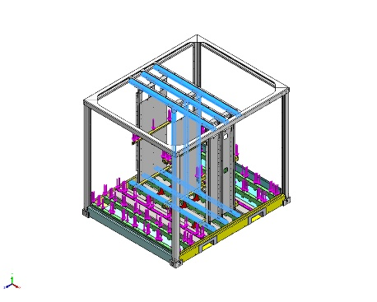 | Name: 1.0539 (S355NH/J2H)  Model type: Linear Elastic Isotropic  Default failure criterion: Unknown  Yield strength: 3.15e+08 N/m^2  Tensile strength: 4.9e+08 N/m^2  Elastic modulus: 2.1e+11 N/m^2  Poisson's ratio: 0.28  Mass density: 7,800 kg/m^3  Shear modulus: 7.9e+10 N/m^2  Thermal expansion coefficient: 1.1e-05 /Kelvin | SolidBody 1(Cut-Extrude1)(FEM2P000013056-1/FEM2P000011093-1/FEM2P000009265-2/FEM2P000009263-1),  SolidBody 1(Cut-Extrude1)(FEM2P000013056-1/FEM2P000011093-1/FEM2P000009265-2/FEM2P000009263-5),  SolidBody 1(Cut-Extrude1)(FEM2P000013056-1/FEM2P000011093-1/FEM2P000009265-2/FEM2P000009263-6),  SolidBody 1(CSK for M1.6 Countersunk Flat Head Screw2)(FEM2P000013056-1/FEM2P000011093-1/FEM2P000009265-2/FEM2P000010224-1),  SolidBody 1(CSK for M1.6 Countersunk Flat Head Screw2)(FEM2P000013056-1/FEM2P000011093-1/FEM2P000009265-2/FEM2P000010224-2),  SolidBody 1(CSK for M1.6 Countersunk Flat Head Screw2)(FEM2P000013056-1/FEM2P000011093-1/FEM2P000009265-2/FEM2P000010224-3),  SolidBody 1(CSK for M1.6 Countersunk Flat Head Screw6)(FEM2P000013056-1/FEM2P000011093-1/FEM2P000009265-2/FEM2P000010328-17),  SolidBody 1(CSK for M1.6 Countersunk Flat Head Screw6)(FEM2P000013056-1/FEM2P000011093-1/FEM2P000009265-2/FEM2P000010328-18),  SolidBody 1(CSK for M1.6 Countersunk Flat Head Screw6)(FEM2P000013056-1/FEM2P000011093-1/FEM2P000009265-2/FEM2P000010328-4)
Curve Data:N/A
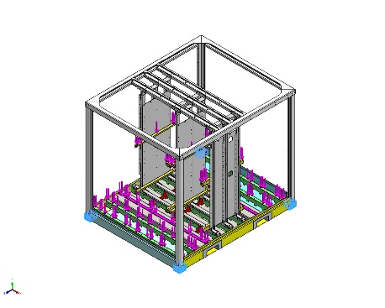 | Name: CARBON STEEL  Model type: Linear Elastic Isotropic  Default failure criterion: Unknown  Yield strength: 2.82685e+08 N/m^2  Tensile strength: 4.25e+08 N/m^2  Elastic modulus: 2.05e+11 N/m^2  Poisson's ratio: 0.29  Mass density: 7,858 kg/m^3  Shear modulus: 8e+10 N/m^2  Thermal expansion coefficient: 1.2e-05 /Kelvin | SolidBody 1(Fillet11)(P000008405FLR-2),  SolidBody 1(Fillet11)(P000008405FLR-3),  SolidBody 1(<P000003232>-<Fillet11>)(P000008411FLR-1),  SolidBody 1(<P000003232>-<Fillet11>)(P000008411FLR-2)
Curve Data:N/A
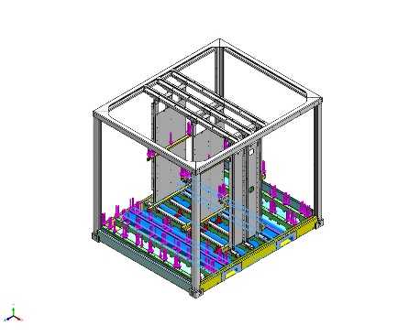 | Name: 1.0577 (S355J2)  Model type: Linear Elastic Isotropic  Default failure criterion: Max von Mises Stress  Yield strength: 3.15e+08 N/m^2  Tensile strength: 4.9e+08 N/m^2  Elastic modulus: 2.1e+11 N/m^2  Poisson's ratio: 0.28  Mass density: 7,800 kg/m^3  Shear modulus: 7.9e+10 N/m^2  Thermal expansion coefficient: 1.1e-05 /Kelvin | SolidBody 1(Boss-Extrude2)(P000014147FLR-1),  SolidBody 1(Boss-Extrude2)(P000014147FLR-2)
Curve Data:N/A

Loads and Fixtures
Fixture name | Fixture Image | Fixture Details
Reference Geometry-1 | 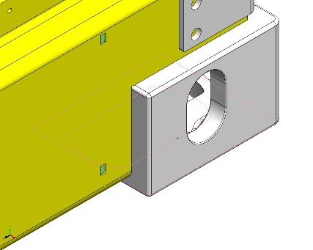 | Entities: 1 vertex(s)  Reference: Face< 1 >  Type: Use reference geometry  Translation: 0, 0, ---  Rotation: 0, 0, 0  Units: mm, rad
Resultant Forces
Components | X | Y | Z | Resultant
Reaction force(N) | -0.000121772 | 8.75885e-05 | 0.000376046 | 0.000404859
Reaction Moment(N.m) | 0 | 0 | 0 | 1e-33

Virtual wall-2714 | 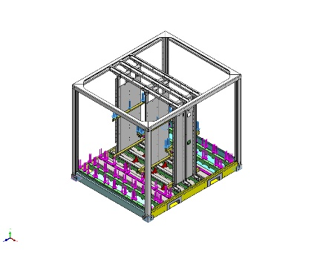 | Type: Virtual wall  Entities: 4 face(s), 1 plane(s)  Wall Type: Rigid

Load name | Load Image | Load Details
Force-2 | 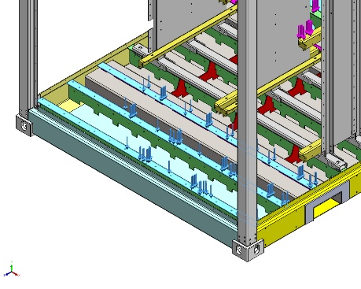 | Entities: 3 face(s)  Type: Apply normal force  Value: 2,180 kgf
Force-3 | 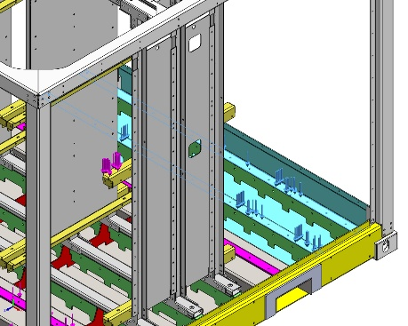 | Entities: 2 face(s)  Type: Apply normal force  Value: 500 N
Force-4 | 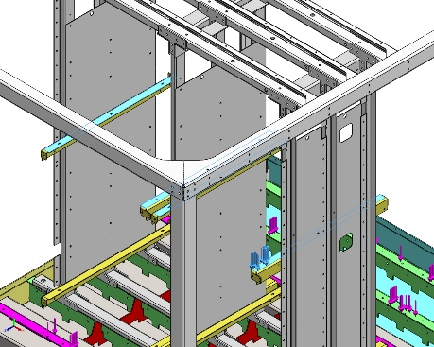 | Entities: 4 face(s)  Type: Apply normal force  Value: 113,000 N

Connector Definitions
No Data

Contact Information

Contact | Contact Image | Contact Properties
Contact Set-19483 | 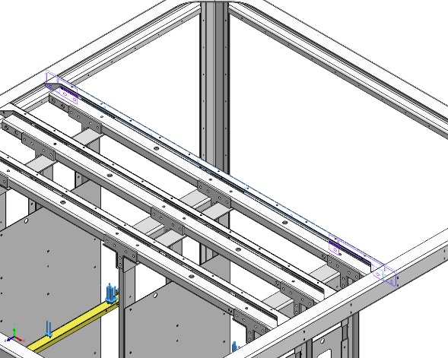 | Type: Bonded contact pair  Entities: 3 face(s)
Contact Set-19484 | 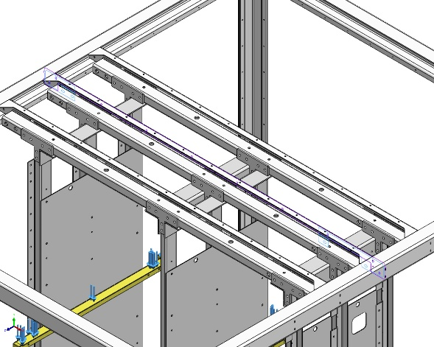 | Type: Bonded contact pair  Entities: 3 face(s)
Contact Set-19485 | 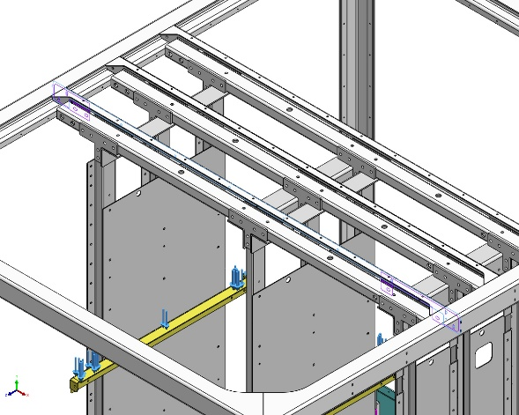 | Type: Bonded contact pair  Entities: 3 face(s)
Global Contact | 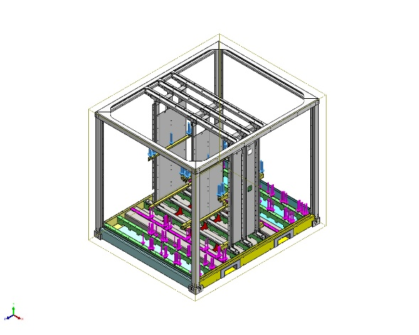 | Type: Bonded  Components: 1 component(s)  Options: Incompatible mesh

Mesh information
No Data

Sensor Details
No Data

Resultant Forces

Reaction forces
Selection set | Units | Sum X | Sum Y | Sum Z | Resultant
Entire Model | N | -0.000121772 | 8.75885e-05 | 0.000376046 | 0.000404859

Reaction Moments
Selection set | Units | Sum X | Sum Y | Sum Z | Resultant
Entire Model | N.m | 0 | 0 | 0 | 1e-33

Free body forces
Selection set | Units | Sum X | Sum Y | Sum Z | Resultant
Entire Model | N | -0.0156679 | -0.44488 | -0.0259589 | 0.445912

Free body moments
Selection set | Units | Sum X | Sum Y | Sum Z | Resultant
Entire Model | N.m | 36.1807 | -2.50136 | 0.117418 | 36.2673

Beams
No Data

Study Results
No Data

Conclusion

